**OVERVIEW OF THE COMPANY**

**1.1 ABOUT ETERNAL**

Eternal soft solutions is a web development based consulting company located in Ahmedabad, India. Established in 2009, Eternal has established itself as a pioneer in the field of cloud based solutions provider. Eternal provides solutions for a wide range of businesses ranging from individual freelancers to small or medium sized startups to even global businesses

The name ‘Eternal’ means everlasting, or something that lasts forever and that meaning has been taken literally across every solution that eternal provides. The solutions built by eternal are scalable, robust and stand the test of time

**1.2 SCOPE OF WORK**

Eternal provides services across a vast variety of sectors such as hospitality, management, tourism,education and development and food and restaurant industry. They have worked with big giants like google, yamaha and honey splash

**1.2.1 Principles of Eternal**

* Openness and trust
* Teamwork and support
* Ingenuity

**1.2.2 Mission of Eternal**

Eternal’s mission is to delight our clients by satisfying their needs through effective utilisation of the best and the most promising new technologies and exceed their expectations by thriving on a continuous improvement of our Services, Business Processes, and Capabilities of its people.

**1.3 OVERVIEW OF THE DEPARTMENTS AND THE TECHNICAL SPECIFICATIONS USED BY THEM**

Eternal soft solutions has two divisions: Cloud development division and Web Development division

* The cloud development division takes care of designing the architecture of the project, determining the project scope, monitoring the health and status of the project and debugging errors. They give solutions centred mainly around the popular cloud providers AWS and GCP but occasionally add tools such as Docker, Jenkins and Kubernetes
* The web development division is a lot more hands-on and implements the solutions given by the cloud development team using front end and back end technologies such as PHP, MYSQL, Apache, NODEJS, React, HTML, CSS, Python, C++, AWS and GCP

**1.3 ORGANISATION CHART**

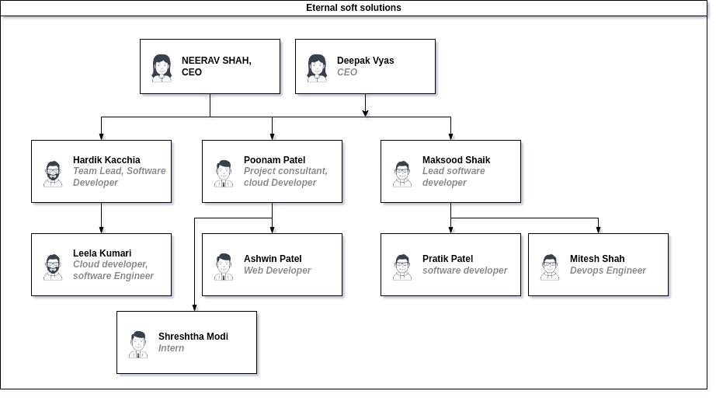

Fig 1.1 Organization chart of Eternal soft solutions